**Mobile App Prototype**

Mamdouh Zayed

Colorado State University Global

CSC505: Principles of Software Development

Dr. Pubali Banerjee

April 29, 2024

**Program Plan for Preliminary Architectural Design and Paper Prototype Script for a Shopping List App**

**Preliminary Architectural Design:**

Utilize UML (Unified Modeling Language) for architectural design.

Create a Python class (ShoppingListApp) to represent the app.

Include methods for adding, removing, and viewing items in the shopping list.

Instantiate the app, perform operations (add, remove), and view the current list.

**Paper Prototype:**

Sketch key screens for the paper prototype, including the main shopping list view, adding an item, and removing an item.

**Development Tools:**

Utilize Python for scripting the pseudocode.

Use UML for architectural design.

The pseudocode outlines the basic structure and functionality of the Shopping List App, and the tool list highlights the tools employed during the development process. The Python script acts as a representation of the initial steps in planning and designing the app.

To create a preliminary architectural design for a mobile app that lets users save a shopping list on their devices, I would first identify the key components and functionalities of the app. This would include user interface, data storage, and the logic for adding, removing, and editing items in the shopping list. I would use a UML tool like UMLet to create diagrams representing the architecture of the app.

For the paper prototype, I would sketch the key screens of the app, such as the main screen showing the shopping list, the screen for adding an added item, and the screen for editing an existing item.

To write a Python script that prints out the names and number of pages in the prototype and the sequence or flow of the pages, I would first create a list of dictionaries, where each dictionary represents a page in the prototype. Each dictionary would contain the name of the page and the number of pages. Then, I would iterate over the list and print out the information.

**Here is the output of the Python codes:**

**Mobile App Prototype for a paper prototype for the shopping list app:**

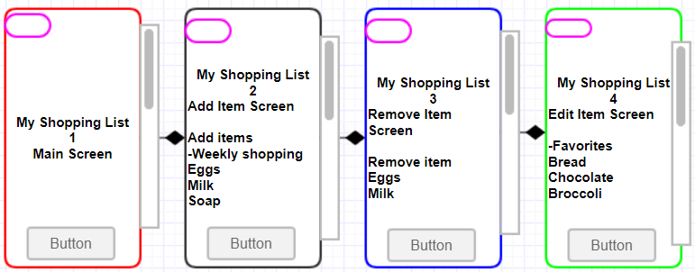

**Here is the My Shopping list diagram:**

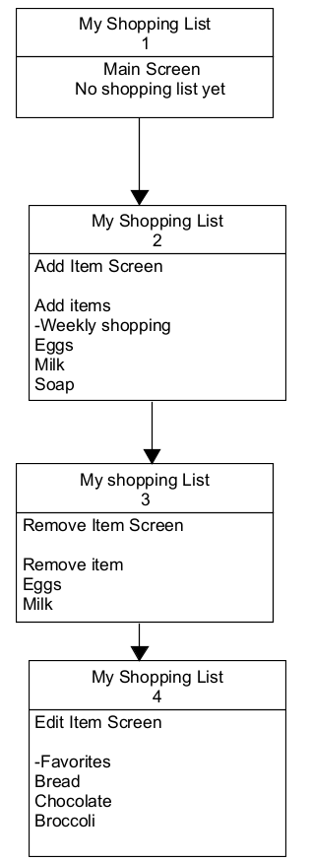

**References**

Ahmad Sahar. (2020). IOS 14 Programming for Beginners: Get Started with Building IOS Apps with Swift 5.3 and Xcode 12, 5th Edition. Packt Publishing.

Eby, K. (2016, July 29). *Comprehensive guide to the agile manifesto*. Smartsheet. https://www.smartsheet.com/comprehensive-guide-values-principles-agile-manifesto

Pressman, R., & Maxim, B. (n.d.). Software Engineering. software-engineering-a-practitioners-approach-9nbsped-9781260548006-1259872971.